Workaround for the copy and paste issues with transfer orders sent by GSA Office of Personal Property Management
---

TRANSFER ORDER COPY AND PASTE WORKAROUND

1. Print to PDF (this will remove the "signature" error message that prevents you from copying and pasting easily). It's important that you print (not save), as that's the way to remove the "lock" that happens on signed documents.

2. Open the "printed" version of the PDF (it should still be an electronic PDF).

3. You can now copy and paste multiple lines … however, it captures too much information. For example, on the subject ICN, when I try to highlight the two lines in box 13, it also selects the TO, HOLDING AGENCY, and SHIP TO boxes (among others - you can see them highlighted in blue below).

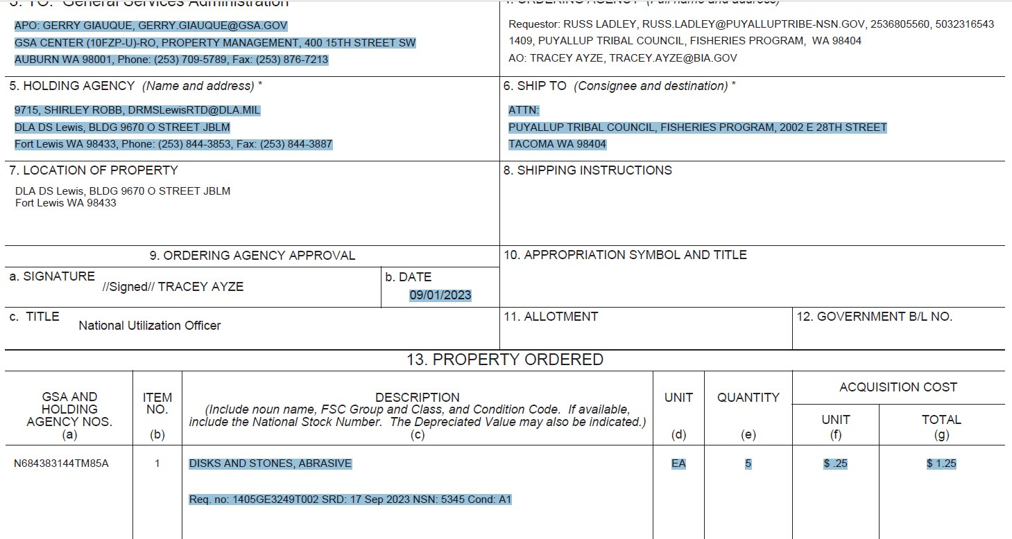

4. Copy and paste the information into Notepad so that it pastes in plain text. You'll end up with something like this:

DISKS AND STONES, ABRASIVE EA 5
ATTN:
PUYALLUP TRIBAL COUNCIL, FISHERIES PROGRAM, 2002 E 28TH STREET
TACOMA WA 98404
APO: GERRY GIAUQUE, GERRY.GIAUQUE@GSA.GOV
GSA CENTER (10FZP-U)-RO, PROPERTY MANAGEMENT, 400 15TH STREET SW
AUBURN WA 98001, Phone: (253) 709-5789, Fax: (253) 876-7213
9715, SHIRLEY ROBB, DRMSLewisRTD@DLA.MIL
DLA DS Lewis, BLDG 9670 O STREET JBLM
Fort Lewis WA 98433, Phone: (253) 844-3853, Fax: (253) 844-3887
Area Property Officer
09/01/2023
09/06/2023
$ .25 $ 1.25
Total Property Ordered $ 1.25
Req. no: 1405GE3249T002 SRD: 17 Sep

5. Delete the information in the center so that you only have the first and last line left:
DISKS AND STONES, ABRASIVE EA 5
Req. no: 1405GE3249T002 SRD: 17 Sep

6. Assuming there are multiple line items, you should only have to remove the extra information once - and then you should have all the lines you need.

