PPMS Issues/Questions List

Updated: 2/6/24

1. Need a back button on the search feature so when we open an item we can return to the search where we left off, with the parameters we entered, it currently takes you back to a new search. You are forced to re-search based on the specific criteria each time. This is incredibly time consuming, and we are hoping can be corrected.

**SASP:** New York, Texas, Nebraska, Missouri, South Dakota

**Reported to GSA?** Yes. GSA Response: We do have an open defect on the reimbursement required search. I'm going to add your notes to that ticket as well.

**Potential Work Around:** Right click over the item to open it in a new window. When you close the 2nd window you should still be in the same spot on your search in the original window.

1. Log in issue. Logged in and selected items for my cart. Was called away and came back 5-10 minutes later. Made me log back in even though I selected keep me logged in for the next 12 hours, and I couldn’t log in.

Had to close out and wait an hour to log in. When I was able to begin the checkout procedure, I had this screen and no way to navigate off of it or check out.

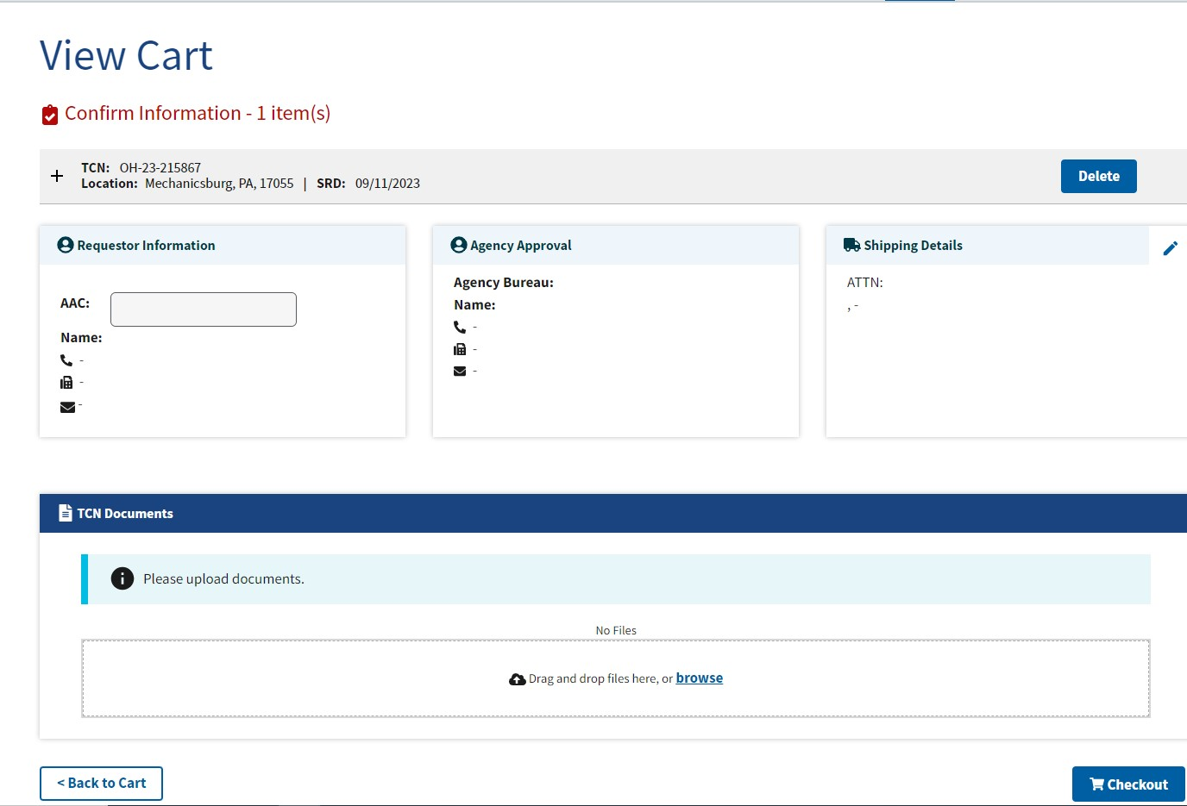

Again, same scenario as above. Logged in the next day and was able to checkout.

**SASP:** Ohio

**Reported to GSA?** Unknown

1. What is the methodology for generating the transfer number? TCN numbers are not controlled by the SASP nor are the automatically assigned numbers sequential. If they can’t be controlled by the SASP, could they at least be sequential so that we can assimilate our records into some sort of filing system? An example of 4 requests made in one morning; the numbers assigned were MT-23-146671, then MT-23-728275, then MT-23-546065, then MT-23-922793.

**SASP:** Louisiana, Montana, South Dakota

**Reported to GSA?** Yes. GSA Response: The TCNs have changed in the new system (and SASPs are no longer able to edit any part of the TCN). The new format is as follows:

○ Alpha state code (NE)

○ 2-digit fiscal year (23 for this year; will update to 24 on 10/1/23) – This is not happening as expected. The system was programmed to change the year with the calendar year and not the fiscal year. NASASP is asking to have that fixed.

○ 6 digits randomly generated (since the numbers are randomly generated, the TCNs

will no longer be in sequential numerical order)

Why was this change made?

○ There were issues with duplicate TCNs in the legacy system; this change will

eliminate the occurrence of duplicate TCNs

○ The system is an MVP system, and having custom TCN control for the SASPs was

deemed non MVP (MVP stands for Minimum Viable Product).

1. Why do we have to see all the old TCNs, it would be better to see newest to oldest if we have to see them all.

**SASP:** Louisiana

**Reported to GSA?** Yes. GSA Response: They will add the ability to sort TCN’s in the future.

**Potential Work Around:** Start search at the bottom of the list.

1. Why can’t we see requested property by location?

**SASP:** Louisiana

**Reported to GSA?** Yes. GSA Response: This is on our enhancements list! Radius search (to enable searching by DLA or other Federal site) is tentatively planned for the second release (date TBD, likely Feb-Apr of 2024)

1. PPMS is not sending the requesting agency the signed TCN email.

**SASP:** Louisiana

**Reported to GSA?** Yes

1. Search by DODAAC – No screening end date prevents screening that piece of property. In the advanced search portion of screening, we would like to be able to still select agencies by their AAC. PPMS has no way that we can see to do this. Only being able to look up property by state is not specific enough and still delays pinpoint screening.

**SASP:** Louisiana, Texas

**Reported to GSA?** Yes. GSA Response: AAC search is available -we've enabled a partial search on the ICN field in advanced search. So if you enter an AAC on the Item Control Number field, the system will return anything reported by that AAC. However, DRMO codes are not available yet in this field so this method really only works well for civilian AACs.

1. We need the ability to search property by DLA location.

**SASP:** Louisiana, Missouri

**Reported to GSA?** Yes.

1. Search Filters need to open as none selected, the person searching for property should be able to select the criteria. When you first log on all the categories are selected which now displays all the property listed in PPMS. I thought there was discussion there was going to be an option to “unselect all”? The way it is now is incredibly tedious, having to manually uncheck each box and then only selecting the categories you are interested in seeing.

**SASP:** Louisiana, Texas, Nebraska, Missouri

**Reported to GSA?** Yes. GSA Response: The feature is already built but we still have to do testing of the feature and it will be released in the first group of updates. I don't have a timeline for the feature release yet but should have it soon. Once I do have a timeline, I will share it with you!

1. Action History – View – is there an easier/faster way to see if a co-worker has already screened property.

**SASP:** Louisiana

**Reported to GSA?** Yes. This issue is no longer relevant as GSA has taken away SASP access to the Action History button and has no intention of bringing it back.

1. DLA’s are loading up by agency, which generates different transfer numbers. This will generate many transfers with different numbers. This is a filing nightmare!

**SASP:** Louisiana

**Reported to GSA?** Yes

1. The font on the 123, Transfer Order is too small. This is un-readable and will create mistakes all because it is a 4 font.

**SASP:** Louisiana, South Dakota

**Reported to GSA?** Yes. GSA Response: We are not planning to change this.

1. In My Tasks, it always says we have zero tasks (see below) when there are actually things we need to do. We need to go in and look up the items that need action individually instead of them showing up automatically on this screen.

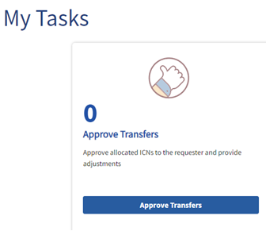

**SASP:** Montana

**Reported to GSA?** Yes

1. Experiencing a lot of issues trying to add items to my cart; either from the property list or by clicking on the item and trying to add it that way. In both cases I am continuously getting an error code and the item is not added to cart.

**SASP:** Texas

**Reported to GSA?** Yes. GSA Response: Generally, this indicates an issue with the item itself.

This issue has been completely corrected.

1. Our SA warehouse is currently inputting property for auction and are experiencing several issues with this action. 1. They are seeing is that they cannot copy and paste any info into the fillable spaces. 2. They noticed that they could not enter or arrow key through to the next fill in space. It must be clicked on using the mouse in order to fill new data. 3. We are receiving multiple email responses from PPMS regarding our auction preparation. It appears the system is sending a response to us for every lot! This is incredibly frustrating getting up to 50-60 response emails. 4. Team would like to see any way to maneuver through the inputting info that doesn’t require having to stop input, click on next fill space, input data and repeat. It is very cumbersome.

**SASP:** Texas

**Reported to GSA?** Yes. GSA Response: 1. They should be able to paste using CTRL + V (vs. right clicking to paste). 2. That is correct. We do have tabbing through the form as an enhancement for the future though. 3. This is a known issue on the Auctions side and Sales has an enhancement planned to address this. TBD on when it will get developed though (you are not the only customer that has reached out, so I'm guessing they will try to get it addressed in the first or second release). 4. Are they able to use the Submit + Report again feature? That should save a lot of time by pre-filling most of the form for them.

1. Trying to use the “print” button on any piece of property, the photos are distorted and not viewable? This makes trying to save and share property with donees difficult as they cannot view the property.

**SASP:** Texas

**Reported to GSA?** Yes. GSA Response: Yes, this is a known defect that has not been fixed yet. I can follow up when it is fixed.

1. Approved Transfer Orders received by SASPs for DLA sites and then the SASPs received notification the property was no longer available.

**SASP:** Alaska, Nebraska, Texas, South Carolina

**Reported to GSA?** Yes. GSA Response: I'm not sure what happened. DLA has just started reporting items back to us and I checked an item, and it was reported on 8/21. Have you reached out to Cassie yet about this? If not, I can send this to her to see if she can investigate on the DLA side.

**NASASP Action:** Tim Bolles reached out to DLA in an attempt to correct the situation before the property was removed from DLA sites.

**DLA Response:** Property has already been allocated to Sales and nothing could be done. This was a management decision to move about 19,500 DTIDs to Sales last week due to warehouse space constraints related to the problems with the PPMS-RTD Web connection. This will not happen again this way, it was a one-time action to relieve stress on our overcrowded warehouses. The total Original Acquisition Value of the DTIDs that were moved to sales and bypassed Donation Allocation was $390,060,258.

**Further Update from DLA:** Each day as the GSA approver approves a transfer order, that transfer order is immediately sent out to the customer and the DLA Disposition Service Site.

At the end of the day PPMS consolidates all of the information and sends our office (RTD Office at Disp Svcs HQ) a file (spreadsheet) with all of the approved transfer orders information, this comes in at approximately 10 p.m.

This information is also sent through Transaction Services, which is the interface between our two systems. As I have mentioned in previous emails, there is an issue due to the length of the Transfer Control number that is not allowing the requisitions to process through Transaction Services into RTD Web. We have found that Transaction services is attempting to manipulate the Transfer Control Number to get some of the request to process.

The day after the transfer orders are approved, GSA is sending our office a copy of all of the transfer orders in case we need to do manual input.

The timing of all of this is why I am sending this email.

Example below

1. SASP request is approved on Wednesday, (field site and customer receive approved transfer order)

2. RTD Office receives the file with the listing of approved request the same day but after duty hours.

3. On Thursday, GSA sends RTD Office a copy of all of the transfer orders that were on Wednesday. So at this point we are already a day behind when the customer and the field site have received the approved transfer order.

Early on our office would immediately begin inputting requisitions, however, we were finding that Transaction Services was manipulating some of the transfer control numbers and some the request sent from PPMS were processing.

The issue is, they do not ALL process. So we had our office inputting manual request while at the same time transaction services was manipulating the same request. Sometimes our manual request would process, sometimes Transaction Services would get the system generated one to process. Depending on the quantity, one of our request would not process, so it was a waste of time for either us to manual input, or transaction services to manipulate it, OR, if there was enough quantity our field sites were receiving both the manual request and the system generated one, when there is only one approved transfer order, meaning they would have to cancel one of the request.

With this being said, we now wait one additional day before we begin inputting manual request. (if there is enough time and the item is not going to roll to sales)

4. So the listing that was sent to us after hours on Wednesday, we received the transfer orders on Thursday, we now wait until Friday to begin inputting manual request once we run all of the requisitions numbers in our system to see how many Transaction Services was able to get to process.

5. We do run the listing when we receive it from GSA to make sure we have that luxury of waiting the additional day. (if the item is in RTD2 on the last day, then we will go ahead and process a manual request)

What we are finding a couple issues:

1. The customer is sending our field sites a Letter of Authorization to Remove (LOAR) the day they receive the Approved Transfer Order. At this time, you do not know if the requisition numbers on the transfer order are the ones that will process through the system. We may need to manually input a new requisition, meaning the requisition number will change and your LOAR is not correct. A new one will have to be submitted.

2. Customers are trying to schedule pick up the same day or the day after they receive the approved transfer order. This does not give our office time to input manual request for the items that Transaction Services is unable to get to process. If the sites does not have an approved request in our system they are not going to be able to release the property.

We ask that you please be patient. This is a very time consuming tasking for our office to take on and we are working the request as fast as we can.

1. It appears that once an item is allocated, it is no longer available or cannot be located in PPMS. This prevents us from being able to go back into PPMS and save photos of items we were allocated. We do this as proof of condition of property and to assist our transportation vendors. This is happening for ALL allocated items. The issue may be with the ICN search function as well as we are unable to look up items by ICN as we receive the same error message.

**SASP:** Texas

**Reported to GSA?** Yes. GSA Response: Data sheets should still be available, but instead of using this search, search for the ICN on Property Requests. You'll have to open your TCN first but then you can view the ICNs and access the data sheets that way (and that's at any point in the allocation process, including after items have been completely donated).

1. The current “size” of the property information blocks in the search menu are way too large. We are only able to see two items on a screen at a time and have to constantly scroll through page after page to see all items. Items can and should be condensed and clean up waste/unused space to fit more items or better yet. Is there any way the property listing can be listed like it is for sales?

**SASP:** Texas

**Reported to GSA?** Yes. GSA Response: We can look into it but overhauling an entire page design will likely not be considered until next year at the earliest. The old search results page in GSAXcess was a source of frequent customer complaint (in our pre-design survey, a lot of customers wanted things significantly larger) so we'd likely have to do a customer survey before making any changes.

1. Would like to have the ability to sort by state again. For example, when you change your advanced search parameters to being a Surplus Release Date - Today, those items would automatically be sorted by the state they were located in. Alabama first, Wyoming last type of thing, the way GSAXcess was. That would make it so much easier to peruse listings and put together a potential load.

**SASP:** Montana

**Reported to GSA?** Yes

1. TCN's no longer checking out by DLA Site location. DLA didn't know that GSA was changing the check out process by AAC instead of location. DLA is overwhelmed with how many TCNs will now be processed for one location. For example, I had 23 TCN's for property at Ft Riley - all with an SRD of 9/11. That means potentially 23 TCN's to forward to Riley along with 23 LOA's for said property. As you know, this would have been 1 TO under GSAXcess.

**SASP:** Nebraska, Missouri

**Reported to GSA?** Yes, also reported to DLA. GSA Response: TCNs are grouped based on several criteria. The items on the TCN must have the same:

○ Listing AAC

○ Surplus Release date

○ Zip code

○ Priority (if selected)

○ Speciality FSCs are separated from the other FSCs (such as aircraft, vessels,

weapons, or animals)

In the past, DLA has been grouped by DRMO location versus listing AAC. We are working on an enhancement for this for sometime next year.

1. Reimbursable option needs to be a "toggle", once you select YES or NO, you can no longer view all property.

**SASP:** Nebraska

**Reported to GSA?** Yes.

1. Requested to show the amount of property per state.

**SASP:** Nebraska

**Reported to GSA?** Yes. I was informed GSA will add it to the list.

1. Also requested State 2-digit code be added to the end of the TCN, will help show location on initial TCN request.

**SASP:** Nebraska

**Reported to GSA?** Yes.

1. When an item has multiple quantity, please make the quantity available the maximum amount.

**SASP:** Nebraska

**Reported to GSA?** Yes.

1. Receiving emails from PPMS requesting to Approve Transfer’s. When checking the system, it showed 0 Transfer’s to approve.

**SASP:** South Carolina

**Reported to GSA?** Unknown

1. Donees and state agencies should be able to use both portals (PPMS and Auctions) with same email.

**SASP:** Missouri

**Reported to GSA?** Unknown

1. Report clarification on POC and/or Custodian listed in PPMS List, on line public auctions and receipts.

**SASP:** Missouri

**Reported to GSA?** Unknown

1. Is there a Buyer’s list for Auctions to be given to SASP.

**SASP:** Missouri

**Reported to GSA?** Unknown

1. Process for the no bid on auctions. Do SASP determine if that gets relisted or request disposal?

**SASP:** Missouri

**Reported to GSA?** Unknown

1. Users – Ability to view donees by registration date?

**SASP:** Missouri

**Reported to GSA?** Unknown

1. There is a glitch in the PPMS system that is sending "Completely Approved Internal Property Transfer Order #" emails to the SASPs when they sign off on a transfer order. This is mostly impacting DLA transfer orders at this time, although we are checking to see if other TOs are impacted.

**Received in Email from GSA:** We have already reported this to the contractor and identified the likely cause of the defect and hope to have it resolved soon.

**Work Around:** In the meantime, please ignore any system generated email with "Completely Approved Internal Property Transfer Order #" in the title. These TOs are NOT complete until GSA has signed off on them.

1. When opening your cart, your list appears with only the TCN, Location and SRD. We’ve been told the TCN is not trackable, so that leaves us with an SRD and a location only. Nomenclature would be very helpful.

**SASP:** South Dakota

**Reported to GSA?** Unknown

1. When you are using the Property Categories filter and select less than the entire list of categories, then go to the Property List Results and open an item to look at it, when you hit the back key, it reinstates all the categories. This is a major hassle when you want only to look at a single or a couple of categories. Could it stay the way you set it unless you click an option that would say select all?

**SASP:** South Dakota

**Reported to GSA?** Unknown

1. When an item is past it’s SRD date, why is it still in PPMS under the property search?

**SASP:** South Dakota

**Reported to GSA?** Unknown

1. The items in our main screener’s cart cannot be seen. He can sign in but his cart shows zero items, yet when you go to an item he knew was in his card, the Requested By Me field shows a quantity.

**SASP:** South Dakota

**Reported to GSA?** Unknown

1. Help Desk issues. Staff have spent literally hours for several days on the phone with the help desk. She has sent them information and not gotten a response, has called and not gotten any answers or resolution.

**SASP:** South Dakota

**Reported to GSA?** Yes. GSA Response: Christina will look into.

1. TRANSFER ORDER COPY AND PASTE WORKAROUND

1. **Print** to PDF (this will remove the "signature" error message that prevents you from copying and pasting easily). It's important that you print (not save), as that's the way to remove the "lock" that happens on signed documents.

2. Open the "printed" version of the PDF (it should still be an electronic PDF).

3. You can now copy and paste multiple lines … however, it captures too much information. For example, on the subject ICN, when I try to highlight the two lines in box 13, it also selects the TO, HOLDING AGENCY, and SHIP TO boxes (among others - you can see them highlighted in blue below).

4. Copy and paste the information into Notepad so that it pastes in plain text. You'll end up with something like this:

DISKS AND STONES, ABRASIVE EA 5  
ATTN:  
PUYALLUP TRIBAL COUNCIL, FISHERIES PROGRAM, 2002 E 28TH STREET  
TACOMA WA 98404  
APO: GERRY GIAUQUE, [GERRY.GIAUQUE@GSA.GOV](mailto:GERRY.GIAUQUE@GSA.GOV)  
GSA CENTER (10FZP-U)-RO, PROPERTY MANAGEMENT, 400 15TH STREET SW  
AUBURN WA 98001, Phone: (253) 709-5789, Fax: (253) 876-7213  
9715, SHIRLEY ROBB, [DRMSLewisRTD@DLA.MIL](mailto:DRMSLewisRTD@DLA.MIL)  
DLA DS Lewis, BLDG 9670 O STREET JBLM  
Fort Lewis WA 98433, Phone: (253) 844-3853, Fax: (253) 844-3887  
Area Property Officer  
09/01/2023  
09/06/2023  
$ .25 $ 1.25  
Total Property Ordered $ 1.25  
Req. no: 1405GE3249T002 SRD: 17 Sep

5. Delete the information in the center so that you only have the first and last line left:

DISKS AND STONES, ABRASIVE EA 5

Req. no: 1405GE3249T002 SRD: 17 Sep

6. Assuming there are multiple line items, you should only have to remove the extra information once - and then you should have all the lines you need.

39. PPMS does not include the TCN integration with AssetWorks. That is, the TCN numbers are no longer sent to us nightly. Instead, GSA emails AssetWorks a list of TCN numbers nightly. AssetWorks currently adds the TCNs to your system manually as a courtesy to minimize the impact on your teams. We do our best to get these done each morning, but sometimes that is not possible.

The manual import service was a temporary measure in expectation of the reinstatement of the nightly file, but it does not seem that GSA plans to do that. Unfortunately, the manual import service will expire on December 15, 2023.

**SASP:** Michigan, Georgia, Illinois, Texas, and Florida

**Reported to GSA:** Yes, on 11/8/23. Follow-up sent on 11/15/23. GSA Response: Per Christina, GSA is working on including implementing the API with their spring update, probably in April. Tim sent an email to AssetWorks asking if they would extend the manual import service until April 15, 2024, at which time the API should be implemented. AssetWorks agreed to extend the manual service until January 31, 2024. GSA is looking at the possibility of sending the files directly to SASPs beginning in February 2024 until the API is established.

**Update:** Since 1/31/24 has passed, AssetWorks is no longer providing the manual update service. GSA has agreed to send the transaction file to any SASP that wants it until the API is reestablished, expected in April of 2024.